# [Prolog - Negation as Failure](https://youtu.be/EegjZr0kRXU) viki culo

# Example of substitutions (pag22)

p(a,X) {X/c} = p(a,c) replace every X with c

p(Y,c) {Y/a} = p(a,c) replace every Y with a

p(a,X) {Y/a, Z/X} = p(a,X) replace every Y with a and every Z with X

# Most General Unifier (MGU) (pag23)

# Ex.7 DLV

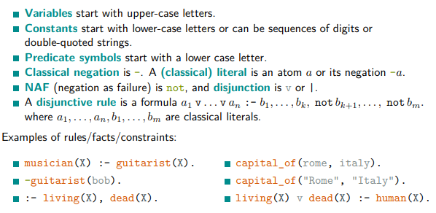

← (implies) becomes :-

^ (and) becomes ,

V (or) becomes ;

¬ becomes -

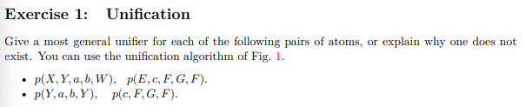

What we want to replace/what is the new “atom”

from variable-> to constants

X, E= d

Y= c

F, W=a

G=b

d/X, c/Y, a/F, b/G, a/W, d/E

Y = c, a = F, b = G, Y = F

Since Y = F, Y = c, and a = F it can no be unified

2.

p(Y, a, b, Y ), p(c, F, G, F).

Solution. Cannot be unified, since F and Y should be mapped to the same value, but Y must

be mapped to c and F must be mapped to a

# Exercise 2: bottom-up and top-down

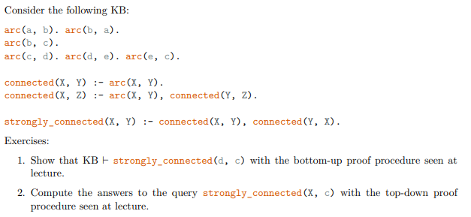

C = ø

C = {

1. arc(a,b)
2. arc(b,a)
3. arc(b,c)
4. arc(c,d)
5. arc(d,e)
6. arc(e,c)

}

“skolemize”

*connected(X,Y) :- arc(X,Y)*

C = {

1. arc(a,b)
2. arc(b,a)
3. arc(b,c)
4. arc(c,d)
5. arc(d,e)
6. arc(e,c)
7. connected(a,b)
8. connected(b,a)
9. connected(b,c)
10. connected(c,d)
11. connected(d,e)
12. connected(e,c)

}

“skolemize”

*connected(X,Z) :- arc(X,Y), connected(Y,Z)*

C = {

1. arc(a,b)
2. arc(b,a)
3. arc(b,c)
4. arc(c,d)
5. arc(d,e)
6. arc(e,c)
7. connected(a,b)
8. connected(b,a)
9. connected(b,c)
10. connected(c,d)
11. connected(d,e)
12. connected(e,c)
13. connected(a,a)
14. connected(a,c)
15. connected(b,b)
16. connected(b,d)
17. connected(b,c)
18. connected(b,d)
19. connected(c,e)
20. connected(d,c)
21. connected(e,d)
22. connected(e,e)

}

“skolemize”

*strongly_connected(X,Z) :- connected(X,Y), connected(Y,X)*

C = {

1. arc(a,b)
2. arc(b,a)
3. arc(b,c)
4. arc(c,d)
5. arc(d,e)
6. arc(e,c)
7. connected(a,b)
8. connected(b,a)
9. connected(b,c)
10. connected(c,d)
11. connected(d,e)
12. connected(e,c)
13. connected(a,a)
14. connected(a,c)
15. connected(b,b)
16. connected(b,d)
17. connected(b,c)
18. connected(b,d)
19. connected(c,e)
20. connected(d,c)
21. connected(e,d)
22. connected(e,e)
23. strongly_connected(a,a)
24. strongly_connected(b,b)
25. strongly_connected(d,c)
26. …

}



1. arc(a,b)
2. arc(b,a)
3. arc(b,c)
4. arc(c,d)
5. arc(d,e)
6. arc(e,c)
7. connected(X,Y) :- arc(X,Y)
8. connected(X,Z) :- arc(X,Y), connected(Y,Z)
9. strongly_connected(X,Y) :- connected(X,Y), connected(Y,X)

yes(X) :- strongly_connected(X,c)

Substitute with rule 9

yes(X) :- connected(X,c), connected(c,X)

CHOICE Substitute with rule 8 the connected(X,c)

yes(X) :- arc(X,Y), connected(Y,c), connected(c,X)

CHOICE CHOICE Substitute with rule 7 connected(Y,c)

yes(X) :- arc(X,Y), arc(Y,c), connected(c,X)

CHOICE CHOICE Substitute with rule 7 connected(c,X)

yes(X) :- arc(X,Y), arc(Y,c), arc(c,X)